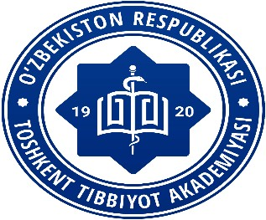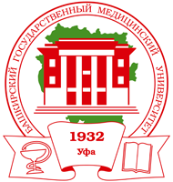

*International Subject Olympiad*

*in Neurology*

*for students of Medical University*

DEAR COLLEAGUES INFORMATION AND INVITATION LETTER!

On October 3, 2023, Tashkent Medical Academy invites students of medical universities to take part in the International Subject Olympiad

in NEUROLOGY

students of 4-5-6 bachelor's courses are invited to participate in the international **online** Olympiad

**Attention to those who want to participate in olympiad:**

All participants of the Olympiad need to register on the website <https://t.me/+rWXbHB1bHFZhYjgy>

until October 2, 2023.

Working languages: Uzbek, Russian and English.

The Olympiad starts at 10:00 Tashkent time

The Olympiad is held in 3 stages:

Stage 1: **testing on the Google test platform**

Stage 2: **solving a situational problem**

Stage 3: **Blitz survey on the Zoom platform**

(details on the Olympiad website)

The number of students is unlimited.

**ALL STUDENTS WHO WANT TO DEMONSTRATE THEIR KNOWLEDGE AND SKILLS IN MEDICINE ARE INVITED TO PARTICIPATE!**

**Organizing Committee of the International Olympiad:**

**Vice-Rector for Research and Innovation :**

Azizova Firuza Lupi yulayevna +998781507802

**Department of Development of research activities of gifted students of TMA**:

Abdumalikova Feruza Bakhtiyarovna +998935467351

**Department of Neurology of BSMU:**

Professor of the department: Leyla Rinatovna Akhmadeeva +73472821420

**Department of Neurology and Medical Psychology:**

Head of the department: Prof. Rakhimbayeva Gulnara Sattarovna +998900380011

Professor of the department: Yakubova Marhamat Mirakramovna +998906038469

Associate Professor of the Department: Rasulova Dilbar Kamaliddinovna +998 901766803

<https://neuro-olympiad.uz>